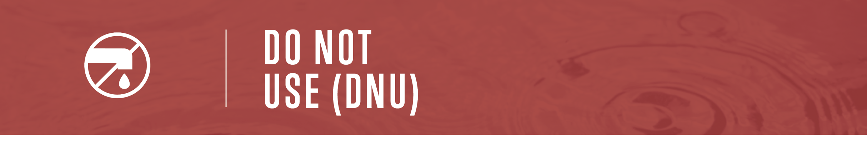

TYPE WATER SYSTEM WATER SYSTEM HAS
ISSUED AN ADVISORY DUE TO: REASON FOR ADVISORY
Do not use this water for any purpose. This includes drinking, making beverages, brushing teeth, food preparation, bathing, water for your pet(s), washing anything (including vehicles), and watering plants.
Do not turn on your taps for any reason. Use an alternate source of water for the purposes mentioned.
Boiling water will not make it safe!
The water in your hot water tank could be unsafe. Consult a qualified plumber before draining tank.

For more information contact Person of contact at Contact information

Check out www.drinkingwaterforeveryone.ca to learn more about water suppliers and current drinking water advisories.

