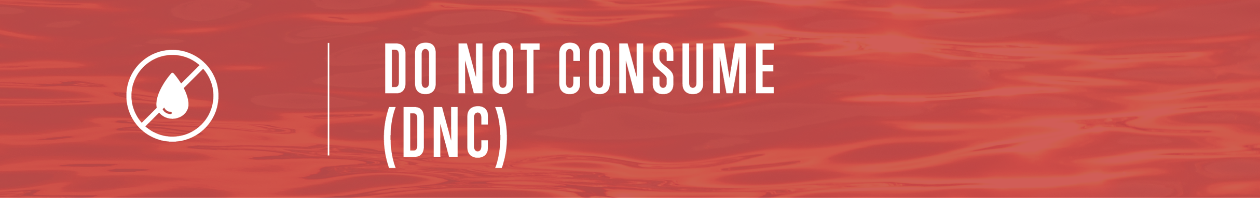

TYPE WATER SYSTEM WATER SYSTEM HAS
ISSUED AN ADVISORY DUE TO: REASON FOR ADVISORY
This water should not be used for drinking, making beverages, brushing
teeth or food preparation. All water users are advised to use an alternate source of water or bottled water for the above purposes.
Boiling water will not make it safe!
It is okay to use the water for household cleaning, bathing and flushing toilets. The water in your hot water tank would also be unsafe for consumption. Please consult a qualified plumber before draining your hot water tank.

For more information contact Person of contact at Contact information

Check out www.drinkingwaterforeveryone.ca to learn more about water suppliers and current drinking water advisories.

